Math 4 Honors Name ______________________________

Lesson 5-7: *Summation Notation* Date ___________________________

**Learning Goals:**

* *I can use summation notation used to write sums.*
* *I can rewrite sums recursively.*

I. The Greek philosopher Zeno of Elea lived around 450 B.C. and is famous for his paradoxes. One of them involves a runner who is trying to go from point A to point B. Zeno pointed out that the runner would first have to go half the distance, then half the remaining distance, and so forth, as shown below.

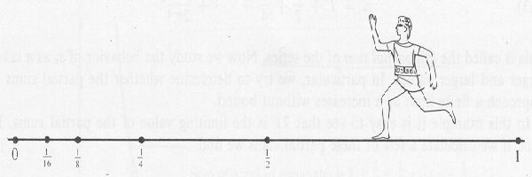

**B A**

0 ⅛ ¼ ½ 1



Zeno observed that the total time required for the runner to reach point B would have to equal the sum of an *infinite* collective of positive numbers:



### This scenario is called The Dichotomy Paradox:

### *“That which is in locomotion must arrive at the half-way stage before it arrives at the goal.”*

### Why is this considered a paradox?

**Summation notation**,or **sigma notation**, is used for representing *sums* such as that arising from the Dichotomy Paradox.

*Summation Notation* (adding consecutive terms in a sequence) is defined as follows:



*index* (assume that *m* and *n* are integers, *m* < *n*)

One way to calculate the sum of the first five terms of the Dichotomy Paradox using summation notation is as follows:



“end”

“begin”

*Expanded Form*

= ____ + ____ + ____ + ____ + ____



= _________________

The **index variable** is the only variable for which values are substituted when the expanded form is written.

OVER 🡪

Page 2

**Examples:**

1. Write in expanded form; then find the value of the sum.



a. b.

2. Write using summation notation: 

3. (a) Re-write the sentence below using summation notation. (b) Then show that it is true for *n* = 5.



II. Writing sums in more than one way:

The index, *i*,of the sum can be replaced by any other variable without changing the meaning of the sum as long as the replacement is made every place in the sum where the index occurs. For example:



Furthermore, this same sum can be generated by modifying the values of *m*, *n*, & the argument of the summation notation. Verify that you get the same sum as above.



**Examples:**

1. Refer back to the summation notation for the Dichotomy Paradox on the front of this paper. Modify *m*, *n*, & the argument of the summation notation so that the expanded form yields the same sum. *Verify that your new form is equivalent to the one on the front.*

Page 3

1. Consider the sum 
   1. Write the expanded form for *n* = 1 and find the sum.
   2. Write the expanded form for *n* = 4 and find the sum.
   3. Write the expanded form for an arbitrary *n*.

III. In the next investigation, we will be doing algebraic proofs by the process of Mathematical Induction.

A key step in the induction process is to be able to *write a sum recursively*. Look at the example below.

Let 

Then, 

So,  =  



In general, is the sum written recursively.

Now you try. Write the following sum recursively.



+

OVER 🡪

Page 4

Putting it all together….



Let *S*(*k*) be the statement:

* 1. Find and show that *S*(5) is true.
  2. Write recursively.
  3. Use (a) and (b) to find.
  4. Based on part c, is *S*(6) is true?

Math 4 Honors Name ______________________________

Lesson 5-7 Homework Date _____________________________





(i.e., write the sum recursively)